Create statefulset.yml:

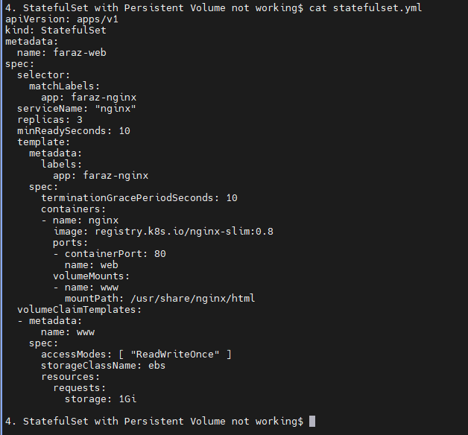

You will see that the pod and pvc is created but they will be in pending status:

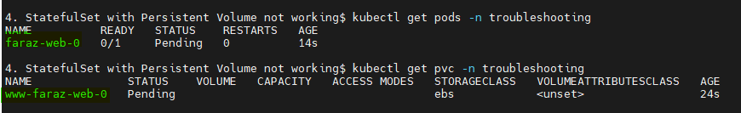

If you describe the pod:

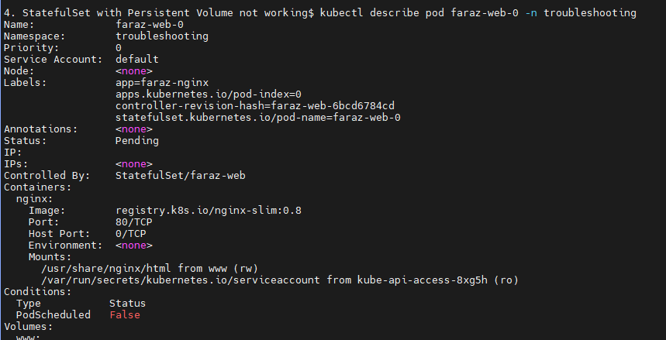



If you describe the pvc:

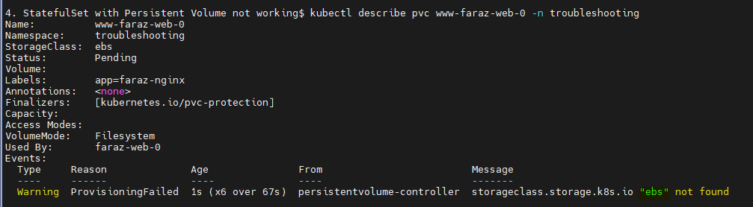

Here the Persistent volume EBS doesn’t exists.

Here the 2nd one will be scheduled only when 1st replica is created.

Flow:

* AWS: StatefulSet -> PVC -> Storage class (EBS) -> Provisioner -> PV
* Minikube: StatefulSet -> PVC -> Storage class (Standard) -> Provisioner -> PV

If we are trying to deploy the same statefulset in minikube which works fine in AWS:

We need to understand the compatibility with the available storage class

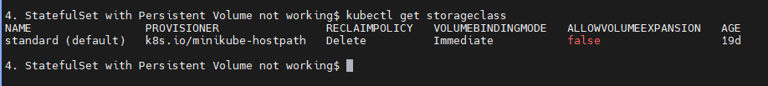

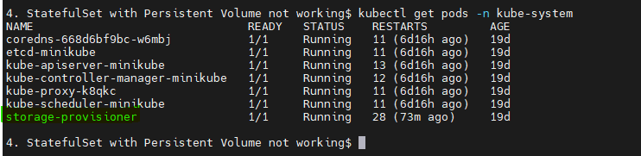

Now to solve this issue, we can delete the statefulsest and add the correct storage class:

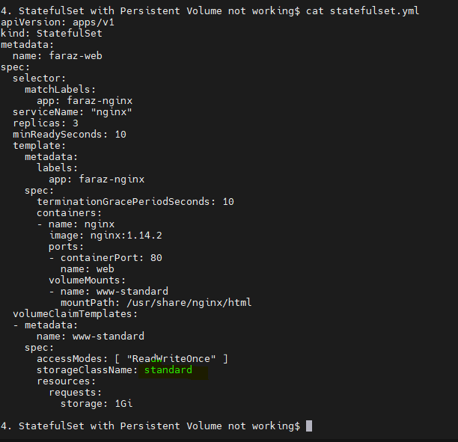

Apply the statefulset:



You will be able to see your pods running:

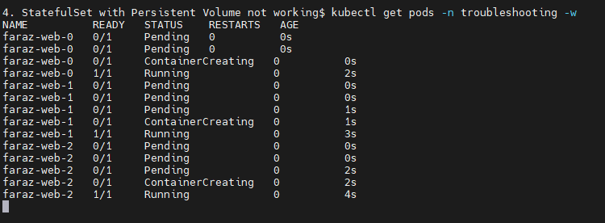

Your statefulset:





If we want to use external storage service like NetApps we will have to use CSI driver which we have to install on EKS cluster, Driver will act as provisioner

* External: Statefulset -> PVC -> Storage Class (NetApp) -> Install CSI driver which acts as Provisioner or talks to provisioner -> Provisioner -> PV